**FAIRNESS IN COVID-19 PANDEMIC: SEXUAL, RACIAL, AND SOCIO-ECONOMICAL**

Team_Baker: Luca Wang, Tracy Zhang, Charlotte Ma, Kerr Tan

**PART1:**

**INTRODUCTION**

*Pleasedeletethissectionbeforedownloading.

**DATASET INTRODUCTION**

*Well-Being and Basic Needs Survey*

*(WBNS)*

2022-10-19 release date

Nationally representative

Internet-based

non-elderly

cross-sectional

topics: health insurance, housing,

food security, employment, family

income etc

**VARIABLES**

ID: Random Unique Identifier

VARUNIT: Cluster grouping for variance estimation Questionnaire Answer: Answers to questions in survey Yes, No, Refused to answer and "."

Properties: Age, Gender, Income etc

**CATEGORIES**

Administrative variables

Survey questions

Demographic variables

Family income

Insurance Status

Marital hardship

School enrollment and child care

**PART 2:**

**EXPLORATORY DATA ANALYSIS**

**BASIC INFORMATION**

RangeIndex: 7737 entries, 0 to 7736

Columns: 392 entries, ID to ANY_CHCR_NOW_DK dtypes: float64(1), int64(188), object(203)

**MISSING VALUE**

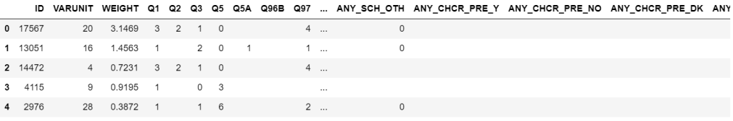**DATA TRANSFORMATION**



special notation: " ","-1"

measure:

changed " " to '-2'

representing 'no

answer'

kept "-1" notation

reprsenting "refused"

most column variables are "object" measure: change to "Int64"

**DEMOGRAPHIC DISTRIBUTIONS**

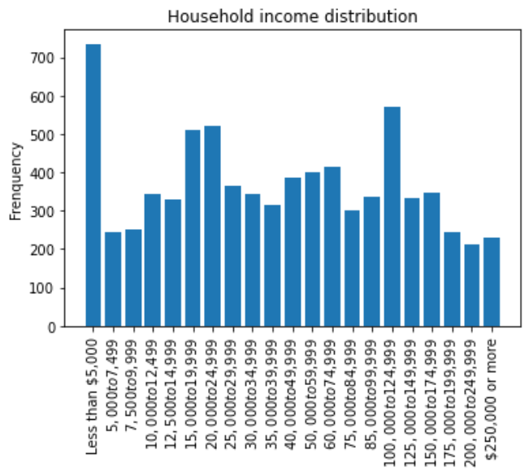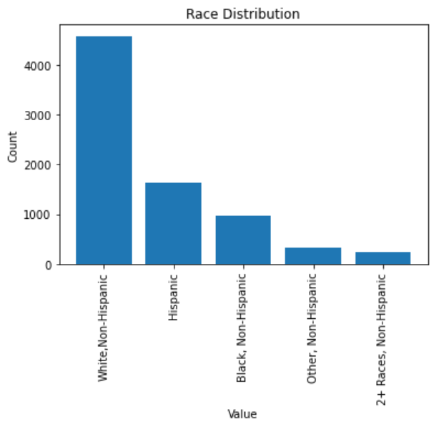

**PART 3:**

**IMPLEMENTATION**

**CLUSTERING (Previous Attemp) on t-SNE (2D Result) 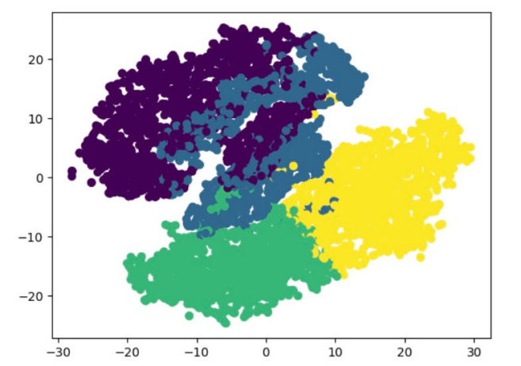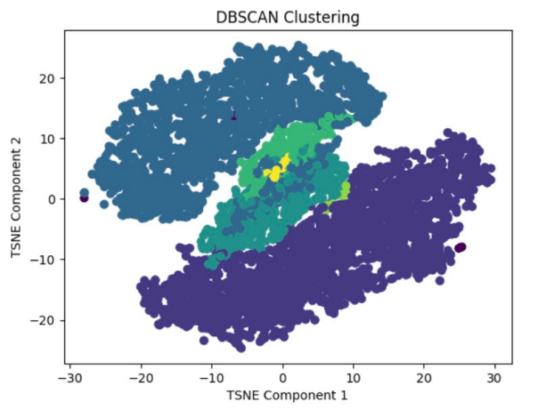K MEANS DBSCAN 2D**

**CLUSTERING 3D**

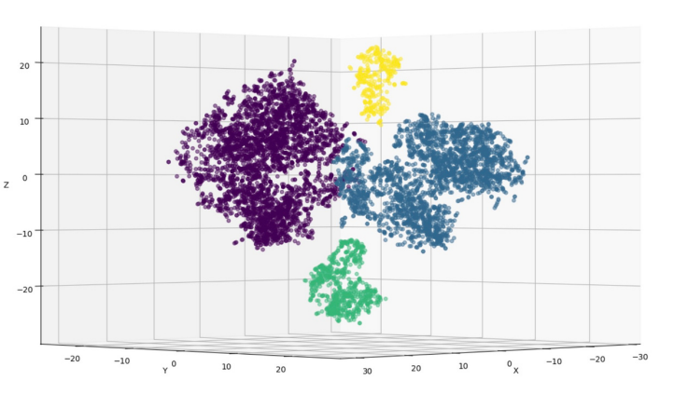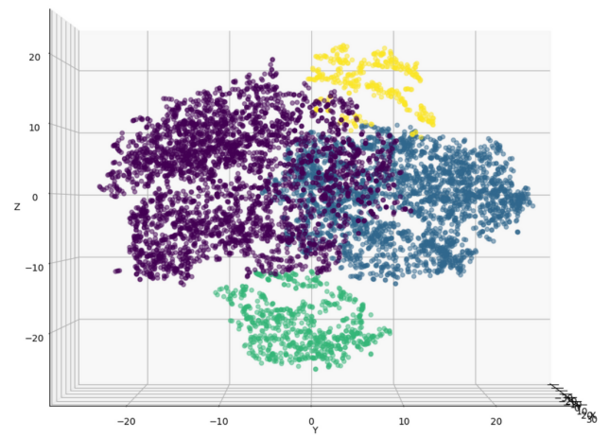**DBSCAN 3D DATA - ZY AXIS DBSCAN 3D DATA - ZYX AXIS**

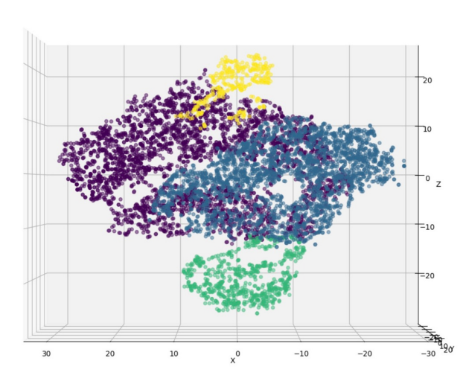

**DBSCAN 3D DATA - XZ AXIS DBSCAN 3D DATA - ZYX AXIS**

**PART 4:**

**OUTCOMES & DISCUSSION**

**CLUSTERING OUTCOMES**

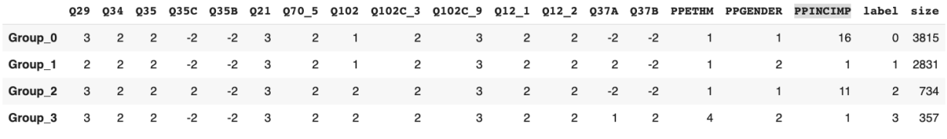**4 clusters with the most common answers for each question**

**NEXT>>> deeper analysis of each question**

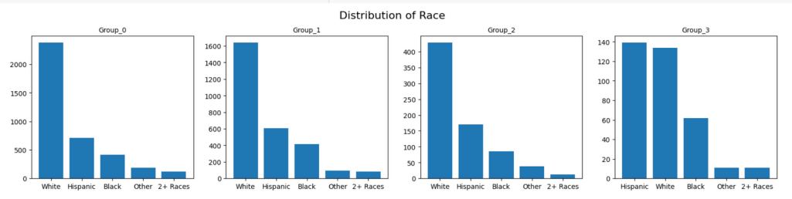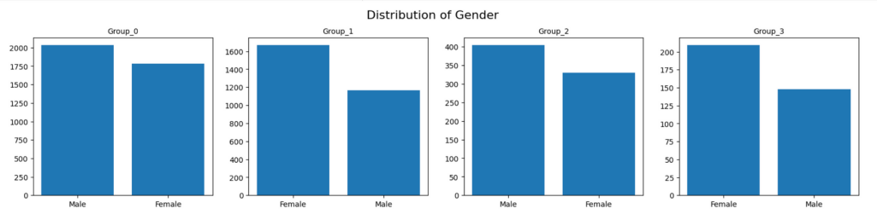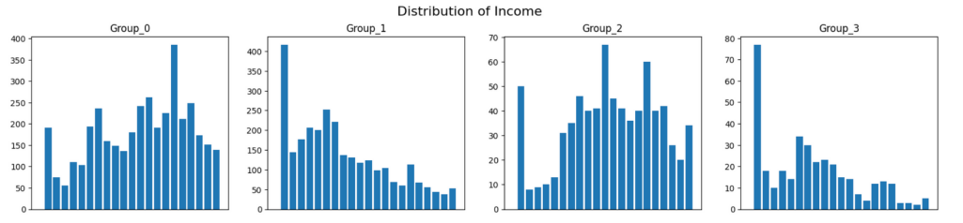

**SPECIFIC QUESTIONS**

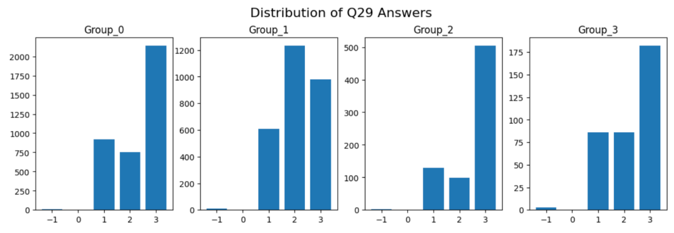

**Q29: Do you currently have a health condition that has lasted for a year or more or is expected to last for a year or more?**

**1: Yes, one condition; 2: Yes, more than 1 condition; 3: No -1: Refused**

**Only Group 1, which is mostly consisted of low-income, female, and White American, has 2 as the most answer to this question.**



**Q35C: Since the coronavirus outbreak began, have any of the children under 6 who are living with you missed a well-child check-up, that is, a general check-up when they were not sick or injured?**

**-1: Yes; -2: not answered; 2: No**

**Only Group 2, which is mostly consisted of male, above-average-income, and white, replied 2 the most**



**Q37A: Are you on temporary layoff from a job?**

**-2: not answered; -1: Refused; 1: Yes, 2: No**

**Group 0 and 2, which are mostly consisted of higher than average income male, mostly did not answer this question.**

**Group 1, which is mostly consisted of low income female and white, mostly said no. Group 3, which is also mostly consisted of low income female, but most are hispanic, but having a smaller size than Group 1, mostly said Yes.**



**Q37B: Has your employer either given you a date to return to work or indicated you will be recalled to work within the next 6 months?**

**-2: not answered; 2: No; 1:Yes; -1: Refused;**

**Group 0, 1 and 2 mostly did not answer to this question, which are all White Americans. However, Group 3, which is mostly consisted of low income female and hispanic, said No.**



**Q102: If a vaccine that protected you from the coronavirus was available for free to everyone who wanted it, how likely would you be to get it?**

**1: definitely get it; 2: probably get it; 3: Would probably NOT get the vaccine; 4: Would definitely NOT get the vaccine; -1: Refused**

**Group 0 and 1 mostly said 1; Group 2 and 3 mostly said 2, where group 0 and 1 are mostly white American, and group 2 and 3 have more hispanic**

**PART 5:**

**CONCLUSION**



**REFERENCE**

***ZUCKERMAN, S. (2022, OCTOBER 19). WELL-BEING AND BASIC NEEDS SURVEY, UNITED STATES, 2020. WELL-BEING AND BASIC NEEDS SURVEY, UNITED STATES, 2020. RETRIEVED APRIL 30, 2023, FROM HTTPS://WWW.ICPSR.UMICH.EDU/WEB/ICPSR/STUDIES/38388/DATADOCUMENTATION#***